homework 4

Yi (Chris) Chen

October 12, 2017

### homework four

#### problem 3.3

##### a. prepare a box plot for ACT score

setwd("C:/Users/cheny/Desktop/study/linear regression model/homework/homework four")  
data_3 <- read.table('3.3.txt',header = FALSE, col.names = c('GPA','ACT','intelligence test score','high school class rank'))  
par(mfrow=c(1,2))  
boxplot(data_3$ACT,main ='box plot of ACT',ylab='ACT score')  
hist(data_3$ACT)

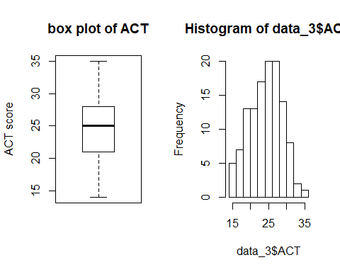

##### c. plot the residual against the fitted values

reg_3 <- lm(data_3$GPA ~ data_3$ACT)  
residual_3 <- reg_3$residuals  
fitted_value_3 <- reg_3$fitted.values  
plot(reg_3,1)

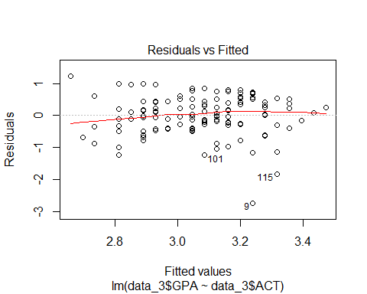

##### d. plot the normal probability plot of residuals.

par(mfrow=c(2,2))  
qqnorm(reg_3$residuals)  
qqline(reg_3$residuals,col="red")  
plot(reg_3,2)  
hist(reg_3$residuals,main = 'hist of residual',xlab = 'residuals')

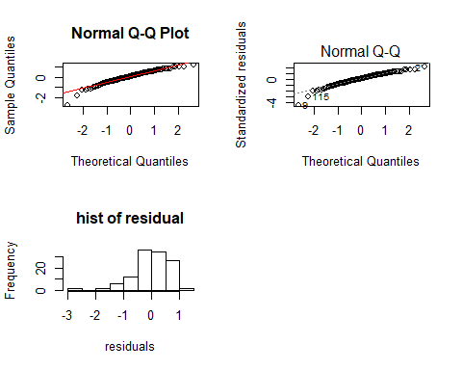

# calculate the coefficient of correlation between ordered residuals and their expected values under normality  
  
ordered_residual <- reg_3$residuals[order(reg_3$residuals)]  
# according to the table B6 (n = 120, ?? = 0.05) z equals to 0.987  
MSE <- sum(reg_3$residuals^2)/(length(reg_3$residuals)-2)  
a <- vector()  
for(i in 1:length(residual_3)){  
 a_new <- ( i - 0.375)/(120 + 0.25)  
 a <- c(a,a_new)  
}  
expected_value <- sqrt(MSE) * qnorm(a)  
correlation <- cor(ordered_residual,expected_value)  
correlation

## [1] 0.9737275

##### e. Brown-Forsythe Test

# order the ACT  
low_26 <- which(data_3$ACT < 26)  
residual_low <- residual_3[low_26]  
  
up_26 <- which(data_3$ACT >= 26)  
residual_up <- residual_3[up_26]  
  
median_low <- median(residual_low)  
median_up <- median(residual_up)  
  
d_low <- vector()  
for( i in 1:length(residual_low)){  
 d_low_new <- abs(residual_low[i]-median_low)   
 d_low <- c(d_low,d_low_new)  
}  
  
d_up <- vector()  
for( i in 1:length(residual_up)){  
 d_up_new <- abs(residual_up[i]-median_up)   
 d_up <- c(d_up,d_up_new)  
}  
  
mean_d_low <- mean(d_low)  
mean_d_up <- mean(d_up)  
  
diff_low <- vector()  
for(i in 1:length(d_low)){  
 diff_low_new <- (d_low[i] - mean_d_low)^2  
 diff_low <- c(diff_low,diff_low_new)  
}  
  
diff_up <- vector()  
for(i in 1:length(d_up)){  
 diff_up_new <- (d_up[i] - mean_d_up)^2  
 diff_up <- c(diff_up,diff_up_new)  
}  
  
s <- sqrt((sum(diff_up)+sum(diff_low))/118)  
# result of t_BF  
t_BF <- (mean_d_up - mean_d_low)/(0.417275 * sqrt(1/length(residual_up)+1/length(residual_low)))  
#calculate t_critical  
t_critical <- qt(0.995,118)  
  
# test  
abs(t_BF) <= t_critical

## [1] TRUE

##### f. test for potential variables

par(mfrow=c(1,2))  
plot(reg_3$residuals ~ data_3$intelligence.test.score, ylab = 'residuals', xlab='intelligence test score')  
plot(reg_3$residuals ~ data_3$high.school.class.rank, ylab = 'residuals', xlab='high school class rank')

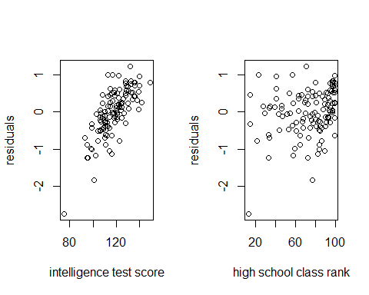

#### problem 3.9

data_9 <- read.table('3.9.txt',header = FALSE, col.names = c('numbrs of rooms','residules'))  
plot(data_9$residules ~ data_9$numbrs.of.rooms,xlab='number of rooms',ylab='residuals' ,main='residuals v.s. predictors')

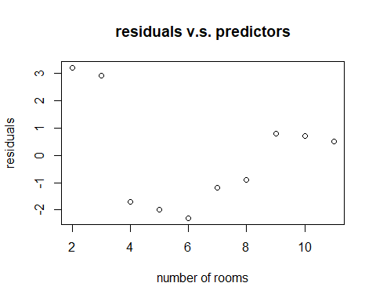

hist(data_9$residules)

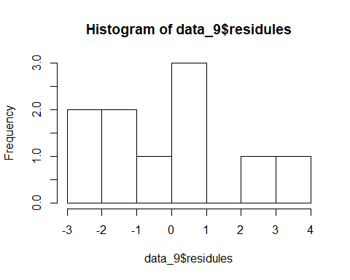

#### problem 3.16

##### a. plot the scatter

data_16 <- read.table('3.16.txt',header = FALSE, col.names = c('concentration of solution','time'))  
plot(data_16$concentration.of.solution ~ data_16$time, ylab='concentration of solution',xlab='time')

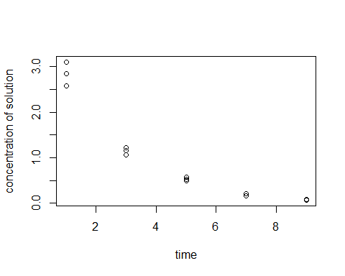

##### b. Box-Cox Transformations

result <- data.frame()  
result$lambda <- vector()  
result$SSE <- vector()  
  
k2 <- prod(data_16$concentration.of.solution)^(1/length(data_16$concentration.of.solution))  
  
# test 0  
wi <- k2*log(data_16$concentration.of.solution)  
reg_16_0 <- lm(wi~data_16$time)  
sse_0 <- sum(reg_16_0$residuals^2)  
result[1,] <- c(0,sse_0)  
  
# test other values  
test <- c(-0.2,-0.1,0.1,0.2)  
for(j in 1:length(test)){  
 i <- test[j]  
 k1 <- 1/(i*k2^(i-1))  
 wi <- k1*(data_16$concentration.of.solution^i - 1)  
 reg <- lm(wi~data_16$time)  
 sse <- sum(reg$residuals^2)  
 result[j+1,] <- c(i,sse)  
}  
print(result)

## lambda SSE  
## 1 0.0 0.03897303  
## 2 -0.2 0.12353047  
## 3 -0.1 0.06505067  
## 4 0.1 0.04396062  
## 5 0.2 0.08131793

# this problem can also be solved in this way  
library(MASS)

## Warning: package 'MASS' was built under R version 3.4.2

tr <- boxcox(data_16$concentration.of.solution~data_16$time,Lambda=seq(-1,+1,20))

## Warning: In lm.fit(x, y, offset = offset, singular.ok = singular.ok, ...) :  
## extra argument 'Lambda' will be disregarded

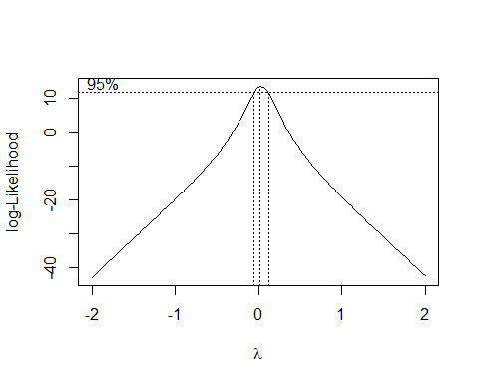

# obviously, lambda should be 0

##### c. estimate the y'

y_dot <- log10(data_16$concentration.of.solution)  
reg_16_c <- lm(y_dot~data_16$time)  
summary(reg_16_c)

##   
## Call:  
## lm(formula = y_dot ~ data_16$time)  
##   
## Residuals:  
## Min 1Q Median 3Q Max   
## -0.082958 -0.044421 0.006813 0.033512 0.085550   
##   
## Coefficients:  
## Estimate Std. Error t value Pr(>|t|)   
## (Intercept) 0.654880 0.026181 25.01 2.22e-12 ***  
## data_16$time -0.195400 0.004557 -42.88 2.19e-15 ***  
## ---  
## Signif. codes: 0 '***' 0.001 '**' 0.01 '*' 0.05 '.' 0.1 ' ' 1  
##   
## Residual standard error: 0.04992 on 13 degrees of freedom  
## Multiple R-squared: 0.993, Adjusted R-squared: 0.9924   
## F-statistic: 1838 on 1 and 13 DF, p-value: 2.188e-15

##### d. print the picture to compare the results

reg_16_orginal <- lm(data_16$concentration.of.solution~data_16$time)  
par(mfrow=c(1,2))  
plot(y_dot~data_16$time,main='after transformation',xlab='time',ylab='concentration.of.solution')  
abline(reg_16_c)  
plot(data_16$concentration.of.solution~data_16$time,main='before transformation',xlab='time',ylab='concentration.of.solution')  
abline(reg_16_orginal)

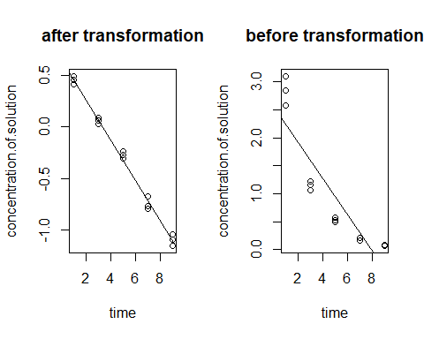

##### e. analysis the new residuals

# residual against fitted value  
plot(reg_16_c,1)

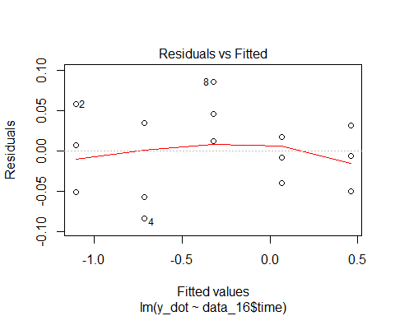

# test normality  
qqnorm(reg_16_c$residuals)  
qqline(reg_16_c$residuals)

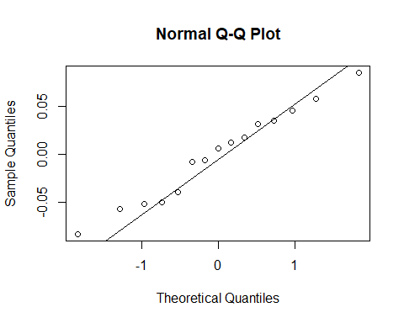

#### problem 24

##### a. estimate the orginal data

data_24 <- read.table('3.24.txt',header = FALSE, col.names = c('blood pressure','age'))  
reg_24 <- lm(data_24$blood.pressure ~ data_24$age)  
par(mfrow=c(1,2))  
plot(reg_24$residuals ~ data_24$age, main='blood pressure v.s. age',xlab='age',ylab='blood pressure')  
plot(data_24$blood.pressure ~ data_24$age)  
abline(reg_24)

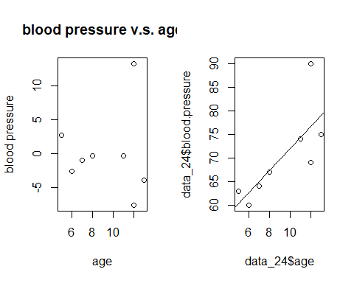

##### b. estimate after omitting one possible outlier

data_24_new <- data_24[-7,]  
reg_24_new <- lm(data_24_new$blood.pressure ~ data_24_new$age)  
par(mfrow=c(2,2))  
plot(reg_24_new$residuals ~ data_24_new$age, main='blood pressure v.s. age',xlab='age',ylab='blood pressure')  
plot(data_24_new$blood.pressure ~ data_24_new$age)  
abline(reg_24_new)  
qqnorm(data_24$blood.pressure)  
qqline(data_24$blood.pressure)  
qqnorm(data_24_new$blood.pressure)  
qqline(data_24_new$blood.pressure)

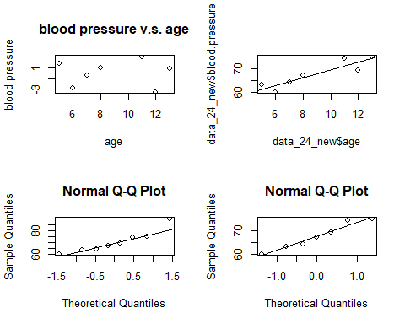

#### Problem 3.31

data_31 <- read.table('3.31.txt',header = FALSE,col.names = c('indentical number','sales prive','finished square feet','nuber of bedrooms','number of bathrooms','air conditioning','garage size','pool','year built','quality','style','lot size','adjacent of high way'))  
set.seed(1)  
# obtain a random sample  
sample_31 <- sample(500,200)  
data_31 <- data_31[sample_31,]  
reg_31 <- lm(data_31$sales.prive~data_31$finished.square.feet)  
summary(reg_31)

##   
## Call:  
## lm(formula = data_31$sales.prive ~ data_31$finished.square.feet)  
##   
## Residuals:  
## Min 1Q Median 3Q Max   
## -192464 -37040 -7041 21842 401946   
##   
## Coefficients:  
## Estimate Std. Error t value Pr(>|t|)   
## (Intercept) -65694.5 20291.9 -3.237 0.00141 **   
## data_31$finished.square.feet 151.3 8.5 17.806 < 2e-16 ***  
## ---  
## Signif. codes: 0 '***' 0.001 '**' 0.01 '*' 0.05 '.' 0.1 ' ' 1  
##   
## Residual standard error: 81630 on 198 degrees of freedom  
## Multiple R-squared: 0.6156, Adjusted R-squared: 0.6136   
## F-statistic: 317 on 1 and 198 DF, p-value: < 2.2e-16

# plot  
par(mfrow=c(2,2))  
plot(reg_31$residuals~data_31$finished.square.feet,main='residuals v.s. predictor', xlab='fished square feet', ylab='residuals')  
qqnorm(reg_31$residuals)  
qqline(reg_31$residuals,col="red")  
plot(data_31$sales.prive~data_31$finished.square.feet,main='x v.s. y',xlab='finished square feet',ylab='sales price')  
plot(reg_31,1)

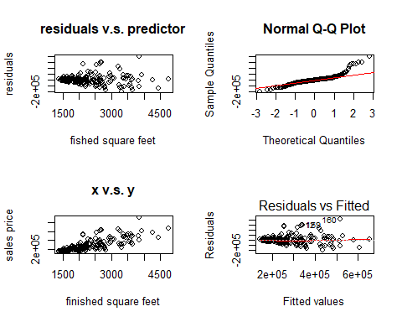

# outlier test  
boxplot(reg_31$residuals)

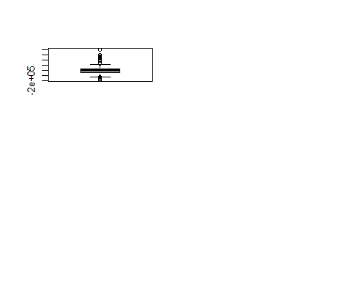

# remove the residual outliers  
outlier <- vector()  
a <- as.numeric(reg_31$residuals)  
for(i in 1:6){  
 new_large <- as.numeric(which.max(a))  
 outlier <- c(outlier,new_large)  
 a <- a[-new_large]  
  
}  
a <- as.numeric(reg_31$residuals)  
for(i in 1:2){  
 new_large <- as.numeric(which.min(a))  
 outlier <- c(outlier,new_large)  
 a <- a[-new_large]  
  
}   
data_31 <- data_31[-outlier,]  
  
# box cox transformation  
library(MASS)  
tr_31 <- boxcox(data_31$sales.prive~data_31$finished.square.feet,Lambda=seq(-2,+2,100))

## Warning: In lm.fit(x, y, offset = offset, singular.ok = singular.ok, ...) :  
## extra argument 'Lambda' will be disregarded

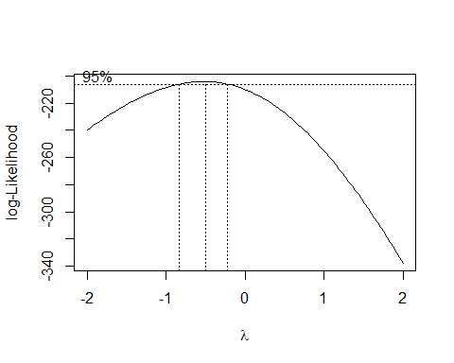

# new regression  
y_new_31 <- data_31$sales.prive^(-1/2)  
new_regress_31 <- lm(y_new_31 ~ data_31$finished.square.feet )  
par(mfrow=c(2,2))  
plot(new_regress_31$residuals~data_31$finished.square.feet,main='new residuals v.s. predictor', xlab='fished square feet', ylab='residuals')  
qqnorm(new_regress_31$residuals)  
qqline(new_regress_31$residuals,col="red")  
plot(y_new_31~data_31$finished.square.feet,main='x v.s. new y',xlab='finished square feet',ylab='new sales price')  
plot(new_regress_31,1)

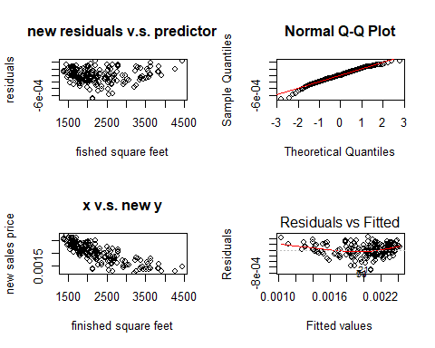

# take into the new x  
y1 <- new_regress_31$coefficients[1] + 1100 * new_regress_31$coefficients[2]  
y1_true <- (1/y1)^2  
y2 <- new_regress_31$coefficients[1] + 4900 * new_regress_31$coefficients[2]  
y2_true <- (1/y2)^2

#### Problem 3.32

data_32 <- read.table('3.32.txt',header = FALSE, col.names = c('identifican number','PSA level','cancer volume','weight','age','benign prostatic hyperplasia','seminal vesicle invasion','capsular penetration','gleason score'))  
reg_32 <- lm(data_32$PSA.level~data_32$cancer.volume)  
summary(reg_32)

##   
## Call:  
## lm(formula = data_32$PSA.level ~ data_32$cancer.volume)  
##   
## Residuals:  
## Min 1Q Median 3Q Max   
## -61.619 -9.023 -1.586 3.151 181.183   
##   
## Coefficients:  
## Estimate Std. Error t value Pr(>|t|)   
## (Intercept) 1.1249 4.3596 0.258 0.797   
## data_32$cancer.volume 3.2299 0.4148 7.786 8.47e-12 ***  
## ---  
## Signif. codes: 0 '***' 0.001 '**' 0.01 '*' 0.05 '.' 0.1 ' ' 1  
##   
## Residual standard error: 32.03 on 95 degrees of freedom  
## Multiple R-squared: 0.3896, Adjusted R-squared: 0.3831   
## F-statistic: 60.63 on 1 and 95 DF, p-value: 8.468e-12

par(mfrow=c(2,2))  
plot(reg_32$residuals~data_32$cancer.volume,main='residuals v.s. predictor', xlab='cancer volume', ylab='residuals')  
qqnorm(reg_32$residuals)  
qqline(reg_32$residuals)  
plot(reg_32,3)  
plot(reg_32$residuals~data_32$PSA.level,xlab = 'residuals',ylab = 'PSA level')

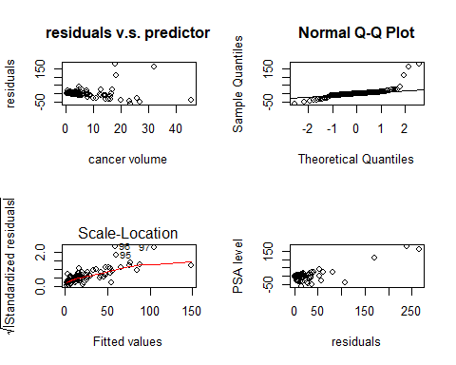

#remove the outlier of predictor  
par(mfrow=c(1,2))  
boxplot(data_32$cancer.volume)  
data_32 <- data_32[order(data_32$cancer.volume)[1:93],]  
  
tr_32 <- boxcox(data_32$PSA.level~data_32$cancer.volume,Lambda=seq(-2,+2,100))

## Warning: In lm.fit(x, y, offset = offset, singular.ok = singular.ok, ...) :  
## extra argument 'Lambda' will be disregarded

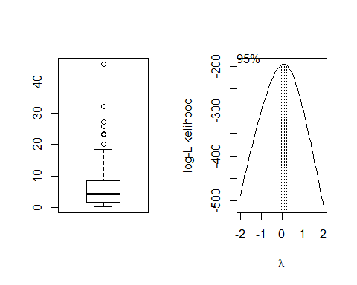

y_new_32 <- log10(data_32$PSA.level)  
new_reg_32 <- lm(y_new_32~data_32$cancer.volume)  
summary(new_reg_32)

##   
## Call:  
## lm(formula = y_new_32 ~ data_32$cancer.volume)  
##   
## Residuals:  
## Min 1Q Median 3Q Max   
## -0.95284 -0.29823 0.07392 0.26147 0.75181   
##   
## Coefficients:  
## Estimate Std. Error t value Pr(>|t|)   
## (Intercept) 0.737802 0.056161 13.137 < 2e-16 ***  
## data_32$cancer.volume 0.051110 0.006878 7.431 5.67e-11 ***  
## ---  
## Signif. codes: 0 '***' 0.001 '**' 0.01 '*' 0.05 '.' 0.1 ' ' 1  
##   
## Residual standard error: 0.3748 on 91 degrees of freedom  
## Multiple R-squared: 0.3777, Adjusted R-squared: 0.3708   
## F-statistic: 55.22 on 1 and 91 DF, p-value: 5.672e-11

par(mfrow=c(2,2))  
plot(new_reg_32$residuals~data_32$cancer.volume,main='new PSA.level v.s. predictor', xlab='cancer.volume', ylab='residuals')  
qqnorm(new_reg_32$residuals)  
qqline(new_reg_32$residuals)  
plot(y_new_32~data_32$cancer.volume,main='x v.s. new y',xlab='cancer.volume',ylab='new PSA.level')  
plot(new_reg_32,1)

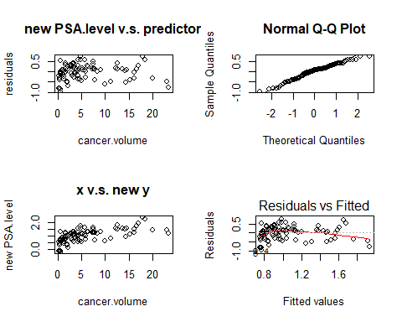

y <- new_reg_32$coefficients[1] + new_reg_32$coefficients[2] * 20  
y_true <- 10^y